Calibration Summary: Finlay

Basin Info
Location | 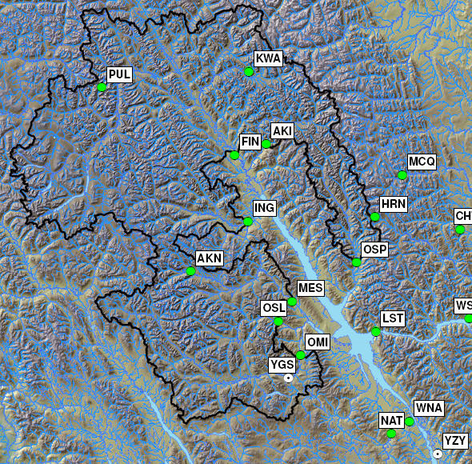
Drainage area | 34049.5 km²
Elevation | Min | 664 m |  |  | Max | 2835 m
Glaciated Area | 1430.0 km² (0.4%)
Hypsographic Curve | 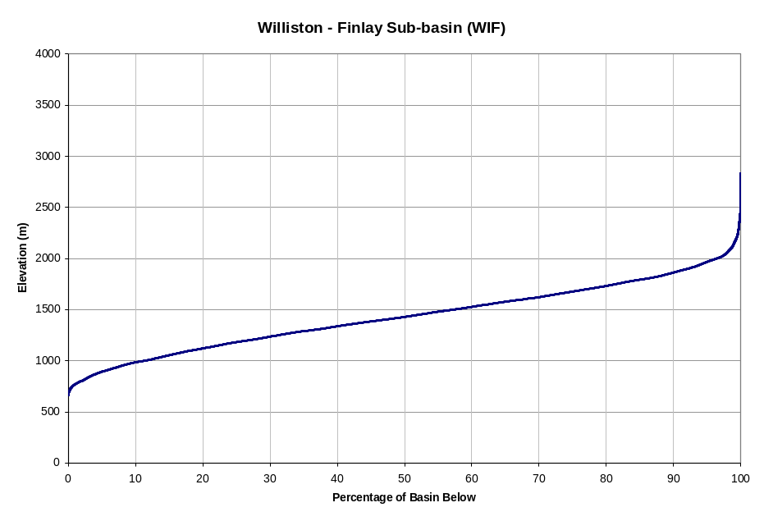
Avg. Annual Precipitation ¹⁾ | 815 mm (PRISM: 726 mm) |  |  | Avg. Annual Snowfall ¹⁾ |  |  |  | 531 mm (65% P)
Avg. Annual Runoff | 532 mm (574 m³/s ; 65% P) |  |  | Avg. Glaciermelt Runoff ¹⁾ |  |  |  | 9 mm (1.7% Q)
Avg. Annual Hydrograph / Hyetograph | 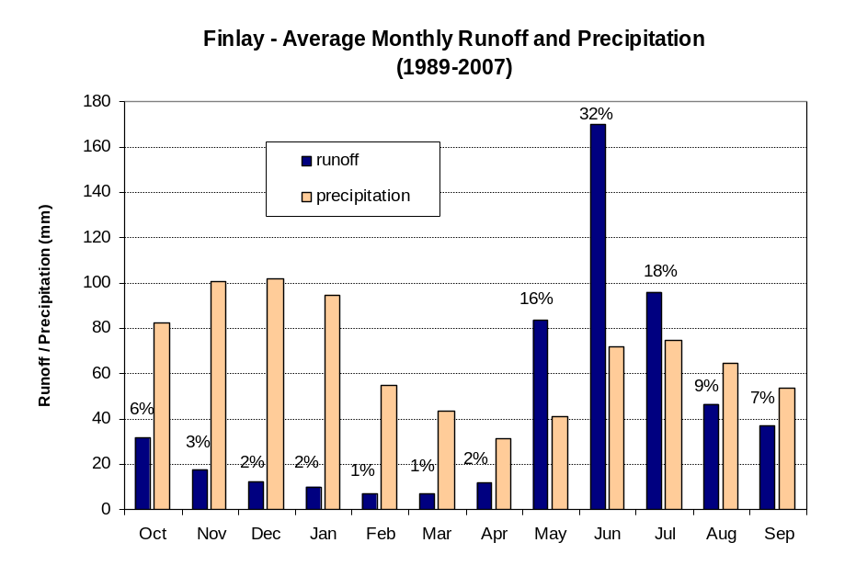
Normal Runoff (1981-2000)² | Month |  | Inflow (cms) |  |  |  | Inflow (10⁶ m³)
Normal Runoff (1981-2000)² | Jan |  | 119.1 |  |  |  | 319.1
Normal Runoff (1981-2000)² | Feb |  | 96.7 |  |  |  | 236.0
Normal Runoff (1981-2000)² | Mar |  | 89.4 |  |  |  | 239.4
Normal Runoff (1981-2000)² | Apr |  | 146.7 |  |  |  | 380.3
Normal Runoff (1981-2000)² | May |  | 1063.9 |  |  |  | 2849.4
Normal Runoff (1981-2000)² | Jun |  | 2116.8 |  |  |  | 5486.7
Normal Runoff (1981-2000)² | Jul |  | 1264.4 |  |  |  | 3386.5
Normal Runoff (1981-2000)² | Aug |  | 635.7 |  |  |  | 1702.6
Normal Runoff (1981-2000)² | Sep |  | 492.3 |  |  |  | 1276.2
Normal Runoff (1981-2000)² | Oct |  | 419.9 |  |  |  | 1124.8
Normal Runoff (1981-2000)² | Nov |  | 228.1 |  |  |  | 591.3
Normal Runoff (1981-2000)² | Dec |  | 156.5 |  |  |  | 419.2
Runoff Regime | Nival
Main Tributaries | Akie River near 740 m contour (AKI), Finlay River above Akie River (FIN), Ingenika River above Swannell River (ING), Mesilinka River above Gopherhole Creek (MES), Ominica River above Osilinka River (OMI), Osilinka River near End Lake (OSI), Ospika River above Alley Creek (OSP)
Best Reference Stream (R²) | Finlay River above Akie River (WSC 07EA005; R² = 0.99)

Notes 1) Estimated from UBC watershed model
2) Data only available beginning in 1981

Calibration Info
Calibration Period | 1989-2007
Verification Period | 1981-1989
# of Elevation Bands | 9
Temperature Data  - Band assignment  - Filename  - Composition  - Station 1  - Station 2  - TS ID | [All bands]  WIFComp.ADC  0.5 FIN + 0.5 YGS  Finlay River above Akie River DCP (FIN; 710 m)  Germansen Landing climate (YGS; 747 m)  100000.1/102.00/314 (312)
Precipitation Data  - Band assignment  - Filename  - Composition  - Station 1  - Station 2  - TS ID | [All bands]  WIFComp.ADC  0.79 FIN + 0.21 YGS  Finlay River above Akie River DCP (FIN; 710 m)  Germansen Landing climate (YGS; 747 m)  100000.1/110.00/315
Flow Data  - TS ID | 100000.1/110.00/315
Parameters  - Filename  - Date | FIN.wat  Dec 31, 2009
Time Constants  - Fast runoff -rain  - Fast runoff - snowmelt  - Fast runoff - glacier  - Interflow - rain  - Interflow - snowmelt  - Upper groundwater  - Deep groundwater | 1.81 days  1.85 days  1.90 days  7.9 days  16.9 days  43.4 days  247.4 days
Folder Name | J:\PS\pso\Hydrology\UBCWM calibration 2008\results\FINAL\GMS\WIF
Modeler | S. Weston

Best-of-ensemble Parameter Set Performance Statistics
Daily  Nash-Sutcliff | Monthly  % volume error |  |  |  |  |  |  |  |  |  |  |  | Yearly  % volume error
 | Jan | Feb | Mar | Apr | May | Jun | Jul | Aug | Sep | Oct | Nov | Dec
2001 calibration, total period (Oct 1 1981 to Sep 30 1994)
0.92 | 22.2 | 26.6 | 16.7 | 10.4 | -2.7 | 1.6 | -2.4 | 6.6 | -5.1 | -25.6 | -2.6 | 10.8 | -0.7
Absynthe, total period (Oct 1 1981 to Sep 30 2007)
0.93 | 21.1 | 28.7 | 23.5 | -9.2 | 2.2 | 2.0 | -4.8 | 4.7 | -9.1 | -26.4 | -5.7 | 11.9 | 0.0
Absynthe, calibration period (Oct 1 1989 to Sep 30 2007)
0.94 | 18.0 | 25.0 | 20.5 | -13.9 | -0.6 | -0.6 | -4.4 | 9.9 | -8.4 | -24.8 | -6.3 | 9.5 | -0.5
Absynthe, validation period (Oct 1 1981 to Sep 30 1989)
0.92 | 29.4 | 38.3 | 30.8 | 5.5 | 10.4 | 8.2 | -5.9 | -5.2 | -10.5 | -28.6 | -3.1 | 18.6 | 0.6

Comments

Additional Documentation
- J:\PS\pso\Hydrology\UBCWM calibration 2008\results\ALU \Alouette2008RecalibrationResults_V2.doc
- J:\PS\pso\Hydrology\UBCWM calibration 2008\documents\UBCWM Recalibration Roadmap\ UBCWM_RecalibrationRoadmap_2ndDRAFT_v1.doc
- J:\PS\pso\Hydrology\UBCWM calibration 2008\documents\UBCWM Recalibration Roadmap\ UBCWM_RecalibrationRoadmap_JULY2008-ADDENDUM_v7.doc
- Scott – DMC analysis
- Scott – GIS analysis

Calibration reviewed by: F. Weber
Date: May 11, 2009

